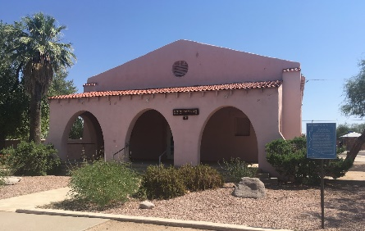

Florence Woman’s Club 231 N. Willow Street, Florence, AZ 85132
Historic Clubhouse Rental Fee Schedule
Total number hours from  check-in to check-out | Price per hour  (plus cost of required insurance and refundable deposit) | Rental Restrictions
1- 4 hours | $38.00 per hour or $140 flat fee - whichever is less  (plus $100 refundable damage/cleaning deposit) | - No decorations  - Rental must be between 10:00 am and 6:00 pm
5- 12 hours | $33.00 per hour or $350 flat - whichever is less  (plus $150 refundable damage/cleaning deposit) | Full-building access  - Rental must end by 10:00 pm
13-24 hours | $30 per hour or $450 flat fee - whichever is less  (plus $150 refundable damage/cleaning deposit) | Full-building access
25-36 hours | $25 per hour or $700 flat fee - whichever is less  (plus $200 refundable damage/cleaning deposit) | Full-building access
37+ hours | $20 per hour  (plus $250 refundable damage/cleaning deposit) | Full-building access

For example, if you want to rent the clubhouse from Friday afternoon (check-in at 6:00 pm) through Saturday night (check-out at 12:00 am), you will rent the club house for 30 hours. 30 hours X $25 per hour = $750; however, the flat fee for 25-36 hours is $700; therefore, the cost of the rental would be the lesser of the two rates. The rental fee in this case is $700 plus a $200 refundable deposit.

For more information, write to FWC, PO BOX 1506, Florence, AZ 86132 or leave a message at (520) 868 8197. Board Approved - 5/25/21

